**SKILLS : PL/SQL PROGRAMMING**

**Exercise 1: Control Structures**

**Control Structures.sql (File Name )**

**Query:**

-- Create customers table

CREATE TABLE customers (

  customer_id   NUMBER PRIMARY KEY,

  name          VARCHAR2(50),

  age           NUMBER,

  balance       NUMBER,

  IsVIP         VARCHAR2(5)

);

-- Create loans table

CREATE TABLE loans (

  loan_id        NUMBER PRIMARY KEY,

  customer_id    NUMBER,

  interest_rate  NUMBER,

  due_date       DATE,

  FOREIGN KEY (customer_id) REFERENCES customers(customer_id)

);

-- Insert sample customers

INSERT INTO customers VALUES (1, 'John Doe', 65, 8000, 'FALSE');

INSERT INTO customers VALUES (2, 'Jane Smith', 45, 12000, 'FALSE');

INSERT INTO customers VALUES (3, 'Emily Green', 70, 15000, 'FALSE');

-- Insert sample loans

INSERT INTO loans VALUES (101, 1, 10.0, SYSDATE + 15); -- due soon

INSERT INTO loans VALUES (102, 2, 9.5, SYSDATE + 40);  -- not due soon

INSERT INTO loans VALUES (103, 3, 11.0, SYSDATE + 20); -- due soon

COMMIT;

BEGIN

  FOR rec IN (

    SELECT c.customer_id, l.loan_id

    FROM customers c

    JOIN loans l ON c.customer_id = l.customer_id

    WHERE c.age > 60

  ) LOOP

    UPDATE loans

    SET interest_rate = interest_rate - 1

    WHERE loan_id = rec.loan_id;

  END LOOP;

  COMMIT;

END;

BEGIN

  FOR rec IN (

    SELECT customer_id

    FROM customers

    WHERE balance > 10000

  ) LOOP

    UPDATE customers

    SET IsVIP = 'TRUE'

    WHERE customer_id = rec.customer_id;

  END LOOP;

  COMMIT;

END;

BEGIN

  FOR rec IN (

    SELECT c.name, l.due_date

    FROM customers c

    JOIN loans l ON c.customer_id = l.customer_id

    WHERE l.due_date BETWEEN SYSDATE AND SYSDATE + 30

  ) LOOP

    DBMS_OUTPUT.PUT_LINE('Reminder: Loan for ' || rec.name || ' is due on ' || TO_CHAR(rec.due_date, 'DD-MON-YYYY'));

  END LOOP;

END;

**OUTPUT:**

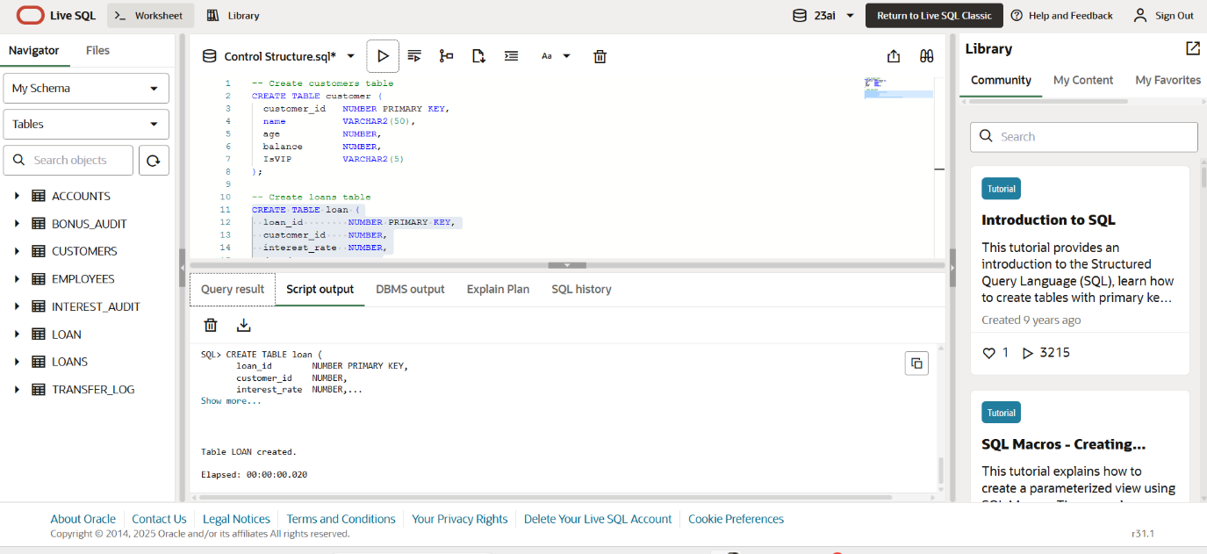

Fig 1.Table Creation.

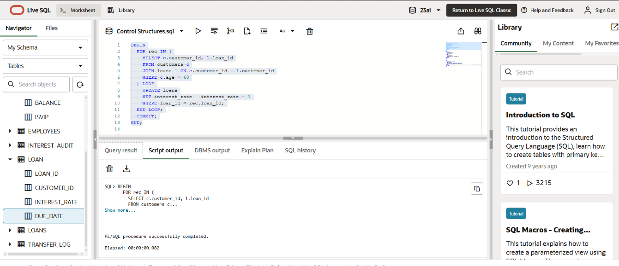

Fig 2. The bank wants to apply a discount to loan interest rates for customers above 60 years old.

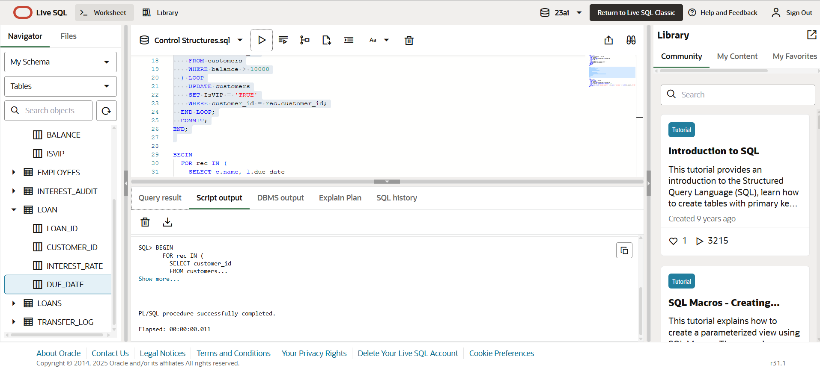

Fig 3. A customer can be promoted to VIP status based on their balance.

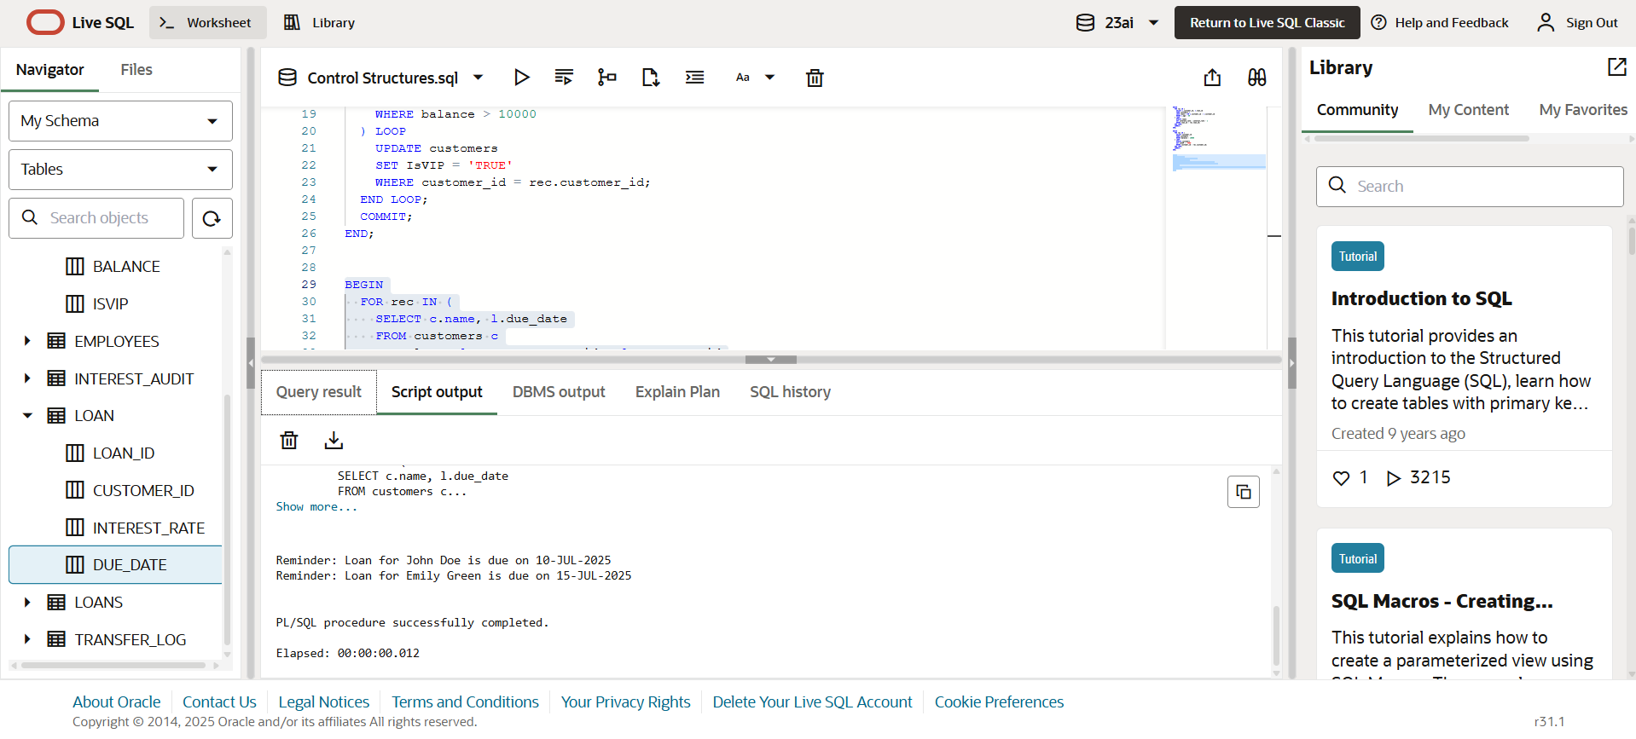

Fig 4. The bank wants to send reminders to customers whose loans are due within the next 30 days.

------END-----

**Exercise 3: Stored Procedures**

**Stored Procedures.sql (File Name )**

**Query:**

-- Drop old tables if they exist

BEGIN EXECUTE IMMEDIATE 'DROP TABLE accounts'; EXCEPTION WHEN OTHERS THEN NULL; END;

/

BEGIN EXECUTE IMMEDIATE 'DROP TABLE employees'; EXCEPTION WHEN OTHERS THEN NULL; END;

/

-- Create accounts table

CREATE TABLE accounts (

  account_id   NUMBER PRIMARY KEY,

  customer_id  NUMBER,

  account_type VARCHAR2(20),

  balance      NUMBER

);

-- Create employees table

CREATE TABLE employees (

  emp_id        NUMBER PRIMARY KEY,

  name          VARCHAR2(50),

  department_id NUMBER,

  salary        NUMBER

);

-- Insert sample accounts

INSERT INTO accounts VALUES (1001, 1, 'savings', 5000);

INSERT INTO accounts VALUES (1002, 1, 'savings', 7000);

INSERT INTO accounts VALUES (1003, 2, 'current', 12000);

-- Insert sample employees

INSERT INTO employees VALUES (1, 'Alice', 101, 50000);

INSERT INTO employees VALUES (2, 'Bob', 101, 45000);

INSERT INTO employees VALUES (3, 'Charlie', 102, 60000);

COMMIT;

CREATE OR REPLACE PROCEDURE ProcessMonthlyInterest AS

BEGIN

  UPDATE accounts

  SET balance = balance + (balance * 0.01)

  WHERE account_type = 'savings';

  COMMIT;

END;

CREATE OR REPLACE PROCEDURE UpdateEmployeeBonus (

  p_department_id IN NUMBER,

  p_bonus_percent IN NUMBER

) AS

BEGIN

  UPDATE employees

  SET salary = salary + (salary * p_bonus_percent / 100)

  WHERE department_id = p_department_id;

  COMMIT;

END;

CREATE OR REPLACE PROCEDURE TransferFunds (

  p_from_account IN NUMBER,

  p_to_account   IN NUMBER,

  p_amount       IN NUMBER

) AS

  v_balance NUMBER;

BEGIN

  -- Get current balance

  SELECT balance INTO v_balance

  FROM accounts

  WHERE account_id = p_from_account;

  -- Check if sufficient

  IF v_balance < p_amount THEN

    RAISE_APPLICATION_ERROR(-20001, 'Insufficient balance.');

  END IF;

  -- Deduct from sender

  UPDATE accounts

  SET balance = balance - p_amount

  WHERE account_id = p_from_account;

  -- Credit to receiver

  UPDATE accounts

  SET balance = balance + p_amount

  WHERE account_id = p_to_account;

  COMMIT;

END;

**OUTPUT:**

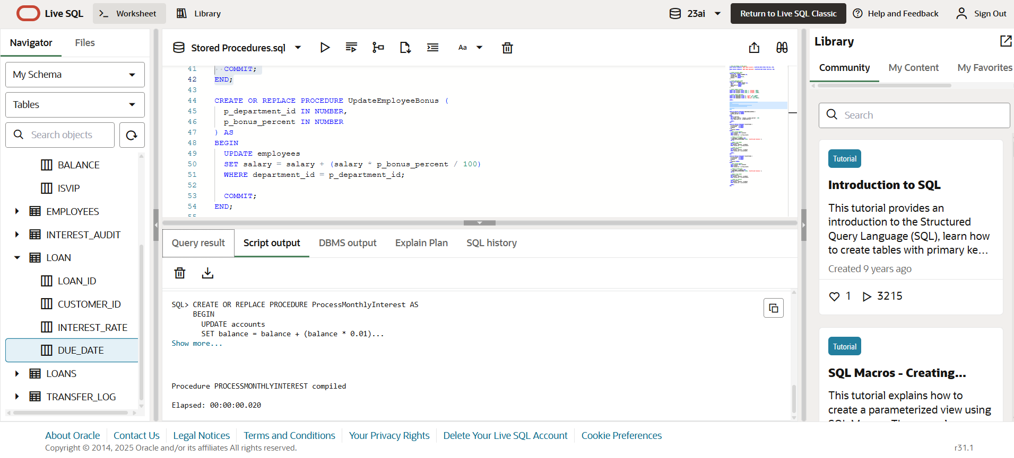

Fig 1. The bank needs to process monthly interest for all savings accounts.

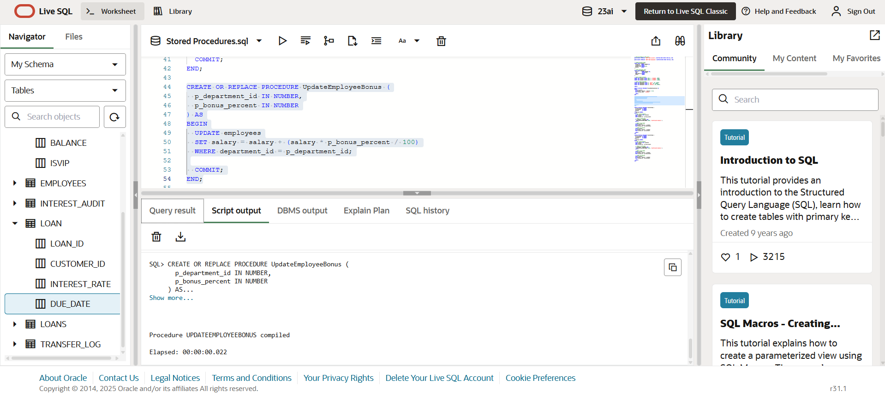

Fig 2. The bank wants to implement a bonus scheme for employees based on their performance.

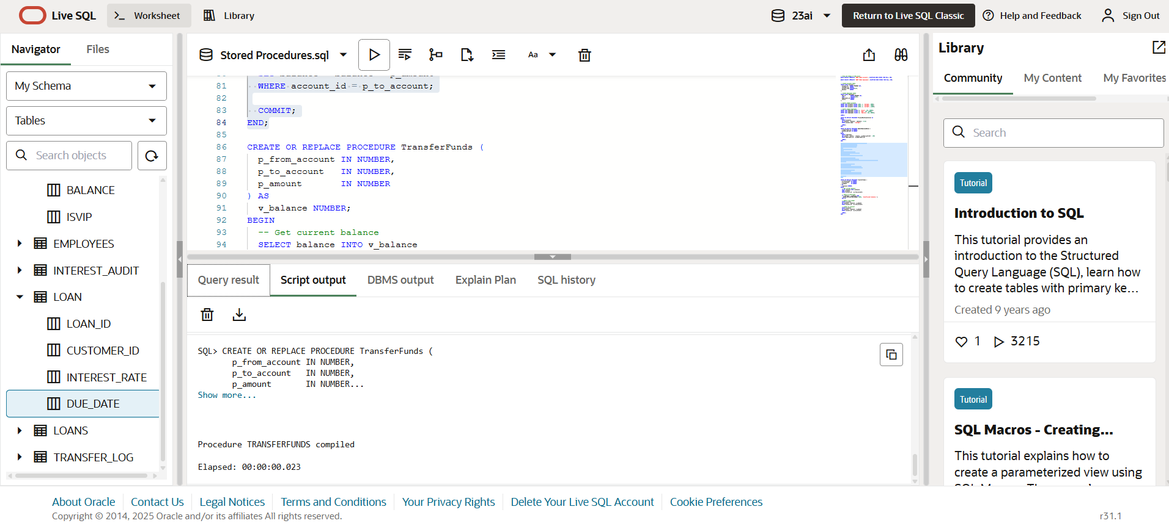

Fig 3. Customers should be able to transfer funds between their accounts.

------END-----